New Ice Age will begin at year 2100.

Victoria Levkine (email mst@mathship.com)

Guennadi Levkine (email hlevkin@gmail.com)

Mathship Technologies
Gibsons, BC, Canada

Abstract. Predictions of climate for short and long periods are very important for human civilization. In this article we predict that new Ice Age will begin at 2100 year AD. This prediction is based on Solar Cycles timing.

Key words: ice age; global warming; global cooling; solar activity; solar circle, solar magnetic field

1. Introduction: problem and terminology

The main problem for our Civilization is Long Term Weather prediction: are we coming to global warming or global cooling? Wrong answer will lead to sad consequences.
In the scientific literature on this issue there are many articles contradicting each other. Most of them prove that we are coming to the Global Warming Period.
We claim that on the contrary we are entering the Global Cooling period. We obtained this result by studying the influence of the Sun's Magnetic Field (SMF) on the Earth.

Terminology:
Definition of Solar Cycle (SC): a process of changing of SMF from zero level to the next zero level.
Moment when SMF equals zero is the border between two Solar Cycles called Transition Year.
Or Transition Year is the year with two Solar Cycles (one cycle ends and another one begins).

This table demonstrates importance of Transition Years Times to the Earth Military History.

SC beginning from 1904 up to 2020 and corresponding wars:
SC 14 1904 Jul 22 Beginning of Russia-Japan War
SC 15 1914 Dec 16 Beginning of First World War
SC 16 1926 Oct 14 Zhang Zuolin's army captures Beijing. The Rif War ends
SC 17 1937 Nov 25 Beginning of Second World War (Nankeen)
SC 18 1948 Jun 10 Cold War and Korean War
SC 19 1959 Sep 10 Cuba: war between Fulgencio Batista and Fidel Castro
SC 20 1971 Jan 11 War between Bangladesh and Pakistan
SC 21 1981 Apr 17 Salvadoran Civil War. Iran - American hostages conflict
SC 22 1990 Jul 6 Cold War ended. Gulf War: Iraq invades Kuwait
SC 23 2000 Jun 23 Second Chechen War
SC 24 2011 Feb 23 Libyan and Syrian Civil wars
SC 25 2020 Dec 26 Conflicts Syria – Turkey, Armenia – Azerbaijan, …

Prediction of the next SC: 2030 Sep 15
Question: which wars will be in that year?

This article proves, using the Transition Years Times that a new ice age will begin in 2100.

2. Additional examples of solar exposure to Earth

Most of important events are happen at Transition Years. Here are some examples of that.

Historical events, randomly selected:
1301 BC: 1300 BC - Moses leads the Hebrews out of Egypt.
1274 BC: The Battle of Kadesh in Syria.
1251 BC: A solar eclipse on this date might mark the birth of Heracles at Thebes, Greece.
0001 AD: Birth of Jesus, as assigned by Dionysius Exiguus
1491 AD: Reconquista- The Granada War is effectively brought to an end
1492 AD: Christopher Columbus expedition makes landfall in the Caribbean
1780 AD: (1781) American Revolution: American and French troops begin a siege of the British at Yorktown, Virginia.

Pandemics examples:
1616 AD New England epidemic
1665 AD Great Plague of London
1769 AD Russian Plague of 1770-1772
1853 AD Third Cholera Pandemic (Russia)

Strongest Tornado in US:
2011 AD Joplin, MO 5/22/2011; 158 dead
1948 AD Woodward, OK 4/9/1947; 181 dead
1937 AD Gainesville, GA 4/6/1936; 203 dead
1937 AD Tupelo, MS 4/5/1936; 216 dead
1893 AD St. Louis, MO 5/27/1896; 255 dead
1843 AD Natchez, MS 5/6/1840; 317 dead
1926 AD Tri-State (MO/IL/IN) 3/18/1925; 695 dead

3. Little Ice Age backward prediction

The main problem in studying of the influence of SMF to Earth's climate is prediction of Global Mean Temperature (GMT) as the function of SMF value. We solved it.
Here are results of using this function for XI-XX centuries:
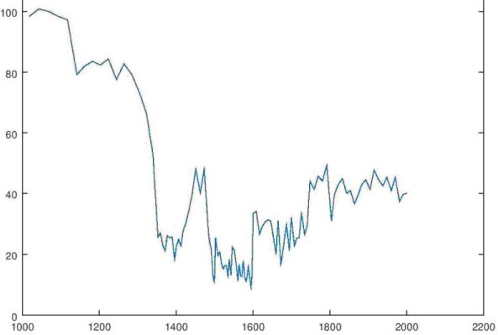

We compared it with the curve of solar activity events recorded in radiocarbon

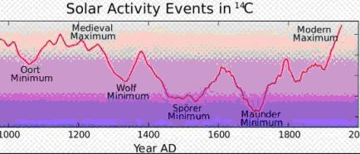
We found that our curve is coinciding to the curve which measured using the carbon method.
On both curves we found The Wolf Minimum, The Spörer Minimum, The Maunder Minimum and Oort minimums.
What are not coincides:
The coldest minimum is Spörer minimum
Wolf Temperature and Maunder Temperature are the same
The temperature in the year 1000 (the middle of Middle Ages) essentially higher of current Temperature.

4. Last Ice Age (LIA) and its beginning/ending times.

Pleistocene is the epoch of the Quaternary period, which began 2.6 million years ago and ended 11.7 thousand years ago. The Pleistocene era replaced the Pliocene and was replaced by the Holocene

LIA happen in the Pleistocene Epoch

LIA began 2.6 millions years ago

It ended 5700 years ago

LIA glacial covering was maximal 18000 years ago

5. Glacial maps of Last Ice Age 18000 years ago.

Glacial map of Europe: look at Picture 1.

Glacial map of North America: look at Picture 2.

Glacial map of the Whole World: look at Picture 3.

The Ice Age 2100 Glacial maps will be close to them.

Terminology:
Homo sapiens is Human - a cultural primacy.

We predict that later Homo sapiens will change (melt) some Glacials using powerful sources of energy.
This planet surface changing will call Planet’s Engineering.

6. Prediction of New Ice Age.

This Ice Age will begin in 2100.

GMT stands for "Global Mean Temperature" of the Earth
GMT is low because it takes into account the entire surface of the Earth, including the Arctic and Antarctica.

In 2020, the GMT will rise by 0.9 degrees Celsius. But this will be accompanied by a strong winter cold snap. For example: the summer temperature will rise by 4 degrees Celsius, but the winter temperature will drop by 3 degrees Celsius.

Here is prediction of Global Mean Temperature (GMT) table from year 2000 up to the year 2200:

year 2020 GMT = 14 degrees Celsius

year 2030 GMT = 15 degrees Celsius

year 2040 GMT = 14 degrees Celsius

year 2050 GMT = 13 degrees Celsius

year 2060 GMT = 13.5 degrees Celsius

year 2070 GMT = 12 degrees Celsius

year 2080 GMT = 12.5 degrees Celsius

year 2090 GMT = 15 degrees Celsius

year 2100 GMT = 9 degrees Celsius Extreme cold snap!

year 2110 GMT = 9 degrees Celsius

year 2120 GMT = 9 degrees Celsius

year 2130 GMT = 10 degrees Celsius

year 2140 GMT = 10 degrees Celsius

year 2150 GMT = 9 degrees Celsius

year 2160 GMT = 7 degrees Celsius
. . . . . . . . . . . . . . . . . . . . . . . . . . . . .
year 4000 GMT = 7 degrees Celsius

Averaged as a whole, the global land and ocean surface temperature for March 2020 was 1.16°C (2.09°F) above the 20th century average of 12.7°C. It equals the first record in the table.

Here is the graph of GMT from year 2000 AD to year 2250 AD:
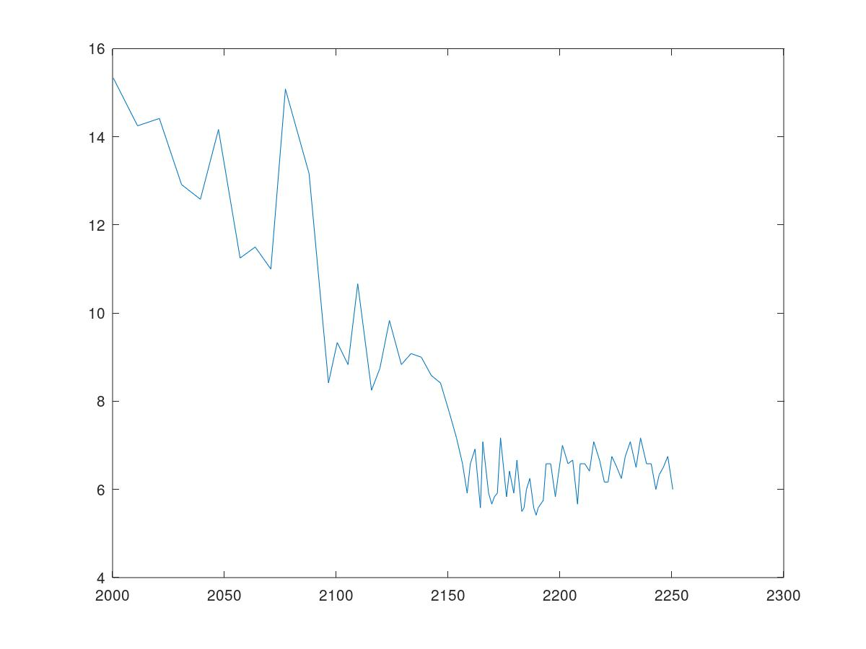

Comments to the table:
2030:
Will be much more problematic than 2020. Summers will be very hot and winters much colder
2040:
Will be like 2020
Period from 2050 to 2080:
There will be a very strong cold snap. GMT will go down from 14 degrees Celsius to 12.5
2080:
Strongest warming - the GMT in a year will jump from 12.5 to 15 degrees Celsius
2100:
The new Ice Age will begin in 2100 with the strongest leap temperatures down 15 to 9 degrees Celsius.
2150:
The GMT will finally stabilize at 7 degrees Celsius.

If reader wants to know what he will see at the end of his life, he can determine it using this table.

8. New Ice Age Prediction plausibility check.

The prediction algorithm was tested by reverse prediction of the GMT during the Little Ice Age (period 1300-1870 of our millennium). (Look at section 3.) The result of the check showed the coincidence of the predicted GST with the measured using the carbon method within the error of measuring.

8. Human civilization development in New Ice Age.
Replacement of Homo in the New Ice Age:

Homo Sapience
They live now and the first 200 years of NIA, most of them will live on Earth.
Look at https://en.wikipedia.org/wiki/Homo_sapiens

Homo Spaciens

They will live in Space (Next 900 years of NIA, intensive immigration to planets, colonizing of them, first star ships)
Look at (http://www.homospaciens.org/)

Homo Galacticus:
They will appear after 1000 years of NIA
Look at (https://www.sciencealert.com/homo-galacticus-how-space-will-shape-the-humans-of-the-future)

9. Fermi paradox resolution.

There are must be a lot of Extra-Terrestrial Intelligent Civilizations In Milky Way, minimum one to 1000 stars. They can be divided onto three types:

- Planetary Civilizations
Colonized their planet
Begin studying their star system

- Star Civilizations
Colonized their star system
Begin studying stars around their star systems

- Galactic Civilizations
Colonized stars around their star
Have intensive contacts with other Galactic Civilizations

It is absolutely unacceptable for Planetary and Star Civilizations to get technologies from higher level civilizations. That is under control of Galactic Civilizations.

Planetary civilizations are most dangerous if they will get such technologies. That’s why we are on special control of Galactic Civilizations; their target is we will have no knowledge about existing of Extra-Terrestrial Intelligent Civilizations (paradox of Fermi).

But now we will move to direction to be Star civilization. Ice Age 2100 stimulate it very strongly. If we will pass that transition, contacts with other civilization are inevitable. But some of civilizations don’t pass it. Result is deadly burned planet.
If we will understand it, we will pass Ice Age test and will move to Star Civilizations Club.

10. Conclusions.

Make it yourself.

Our personal conclusion: We must do all to help Our Civilization to survive.

11. Acknowledgments.

We are very thankful to researchers who created maps on pictures 1, 2 and 3.

Picture 1 (Glacial map of Europe):

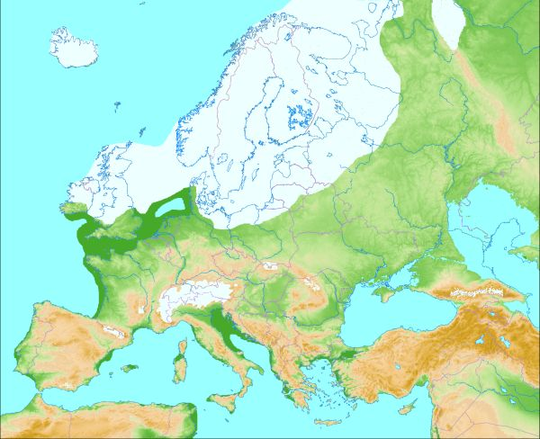

Picture 2 (Glacial map of North America):
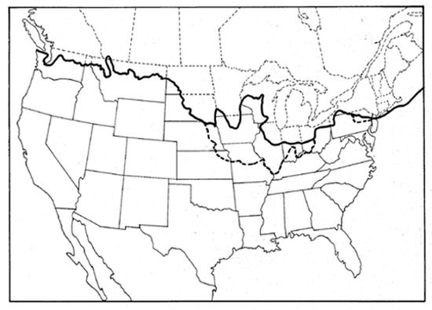

Picture 3 (Glacial map of the Whole World):
