Star Movement under Influence of Two Planets

Guennadi Levkine (email hlevkin@gmail.com)

Mathship Technologies
Gibsons, BC, Canada

Abstract. In this article we study influence of planets on the motion of a star. We are interested in the acceleration of a star under the influence of the surrounding heavy planets. Acceleration determines the motion of plasma in the Star Core. The motion of plasma in the Star Core determines the magnetic field of the Star. This is why analyzing the acceleration of a star is important when studying Solar Activity.

Key words: barycenter; star motion; star acceleration; planet influence; Star Core plasma;

1. Introduction: problem and terminology

The main problem
This article describes …
It proves.

2. History of that Problem studying

The first article

3. Sun Movement around Center of mass of Solar System.

Planet movement defines Sun movement. This is the result of the gravitational interaction between the Planets and the Sun. Not only planets move in orbits around the Sun, but also the Sun relative to the common center of mass. Only the displacement of the Sun is much smaller than the size of the orbits of the planets.

Articles [10], [11], [12] describes the Sun’s Orbital Motion under influence of planets.

Figure 1. The Path of the Center of Mass of the Solar System

Points on Sun trajectory where acceleration is 0 and maximal, times of when is happened.

4. X- and Y-projection graphs of the acceleration of the Star.

5. SMF of the Star

10. Conclusions.

Make it yourself.

11. Acknowledgments.

We are very thankful to researchers who

Appendix A. Sun Trajectory calculation (Matlab program).

#====================================================
K = 1;
N = 1000; # number of steps
T = k * 0.9300e+08; # time interval-Saturn period in secs
step = 1e5;

# Parameters:
g = 6.674e-11; # gamma
# Masses
m1 = 18.98e+26; # Jupiter
m2 = 05.683e26; # Saturn
M = 1.989e+30; # Sun
# Orbits
a1 = 0.81662e+12; b1 = 0.74052e+12 ; # Jupiter
a2 = 1.5145e+12; b2 = 1.3526e+12; #0.9e12 Saturn

# trajectories
jupiterX = zeros(1, N);
jupiterY = zeros(1, N);

saturnX = zeros(1, N);
saturnY = zeros(1, N);

sunX = zeros(1, N+1);
sunY = zeros(1, N+1);
xx = zeros(1, N+1);
yy = zeros(1, N+1);

# initial values of position and velocity
sunX(1) = +200000;
sunY(1) = -700000;
sunVx(1) = 0;
sunVy(1) = 0;

for i=1:(N+1)
#disp('----------------------------');
printf("i= %d ", i);
jupiterX(i) = a1*cos((2*pi/N)*i);
jupiterY(i) = b1*sin((2*pi/N)*i);
saturnX(i) = a2*cos((2*pi/N)*i);
saturnY(i) = b2*sin((2*pi/N)*i);
#printf("%f %f %f %f\n", jupiterX(i), jupiterY(i), saturnX(i), saturnY(i));

r1 = jupiterX(i)^2 + jupiterY(i)^2;
r1 = r1^1.5;
r2 = saturnX(i) ^2 + saturnY(i) ^2;
r2 = r2^1.5;
if i==1
sunAx(i) = g * M * (m1*jupiterX(i)/r1 + m2*saturnX(i)/r2);
sunAy(i) = g * M * (m1*jupiterY(i)/r1 + m2*saturnY(i)/r2);
else
sunX(i)= sunX(i-1)+sunVx(i-1)*step+sunAx(i-1)*step*step/2;
sunY(i)= sunY(i-1)+sunVy(i-1)*step+sunAy(i-1)*step*step/2;

sunAx(i) = g * M * (m1*jupiterX(i)/r1 + m2*saturnX(i)/r2 );
sunAy(i) = g * M * (m1*jupiterY(i)/r1 + m2*saturnY(i)/r2 );

sunVx(i) = sunVx(i-1)+ ( sunAx(i-1) + sunAx(i) )*step/2;
sunVy(i) = sunVy(i-1)+ ( sunAy(i-1) + sunAy(i) )*step/2;
endif
xx(i)=sunX(i)/1e33;
yy(i)=sunY(i)/1e33;
printf("%f %f\n",xx(i),yy(i));
end

#--------------------------------------------------------------------
# trajectories plot
figure;
plot(jupiterX , jupiterY, 'linewidth', 2, "linestyle", ':', 'color', 'g')
hold on
plot(saturnX , saturnY, 'linewidth', 2, "linestyle", ':', 'color', 'b')
hold off

figure;

for i=1:(N+1)
# sunX(i)=sunX(i)/1e33;
# sunY(i)=sunY(i)/1e33;
end

xx=sunX/1e33;
yy=sunY/1e33;

plot(xx(2:N) , yy(2:N), 'linewidth', 2, "linestyle", ':', 'color', 'r')

Literature
- https://en.wikipedia.org/wiki/Barycenter
- Sun motion around Solar System Baricenter https://www.skymarvels.com/gallery/Vid%20-%20Solar%20System%20Barycenter.htmJose Paul D., “The Sun’s Orbital Motion”, Popular Astronomy, Vol. 44, p.542, 1936
- Guerra1, Carvalho, “Orbital motions of astronomical bodies and their Centre of Mass from different reference frames: a conceptual step between the Geocentric and Heliocentric models”, Submitted to Phys. Educ., May 2016
- Lubomir Vlcek “Orbit radius and speed of the Sun around the center of gravity of the Solar System”, http://citeseerx.ist.psu.edu/ Literature viewdoc/download?doi=10.1.1.456.1933&rep=rep1&type=pdf

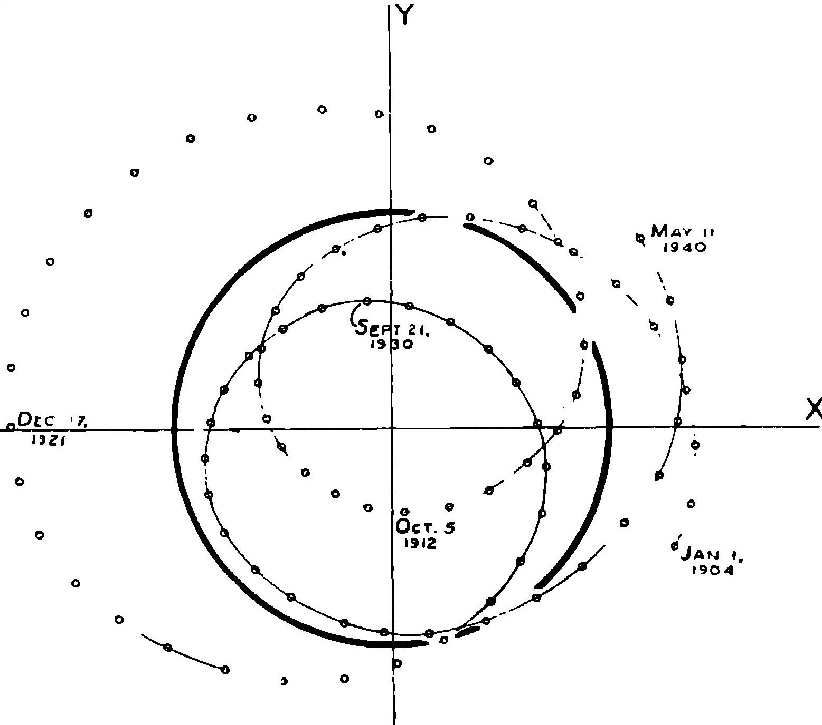

Picture 1. The Path of the Center of Mass of the Solar System referred to the Sun (from [7]).

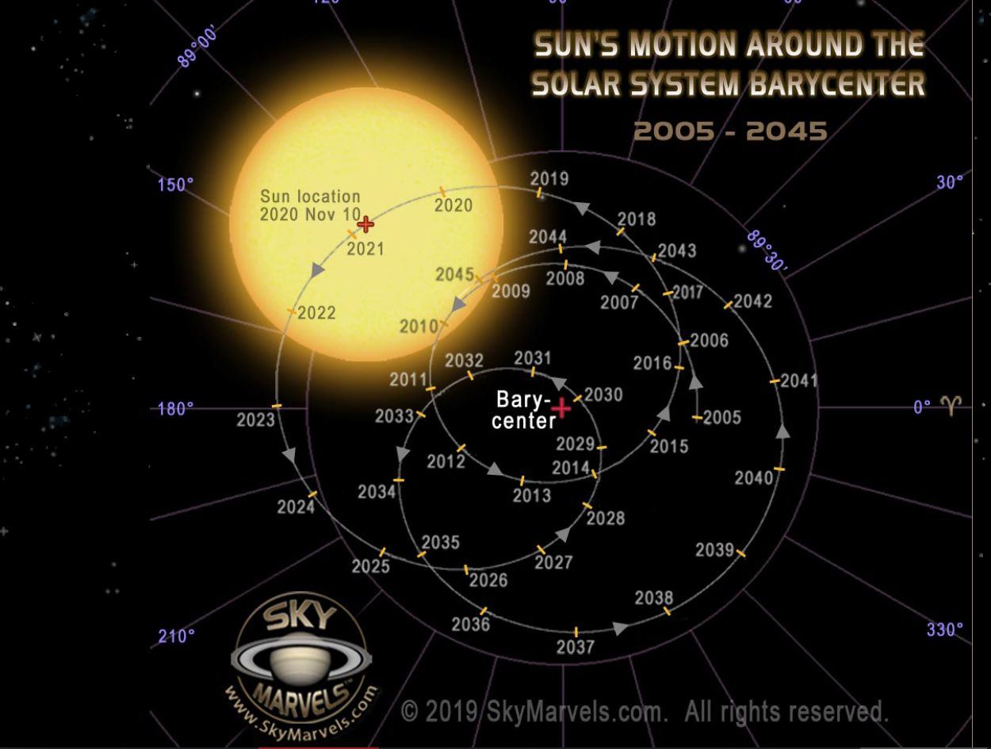

Picture 2.
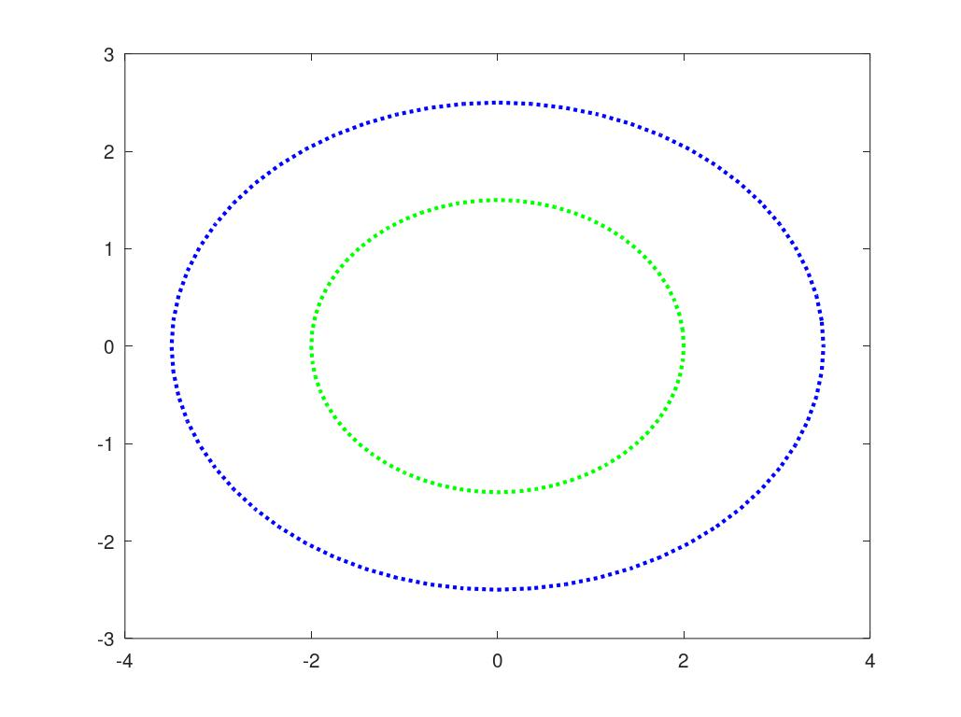
Picture 3

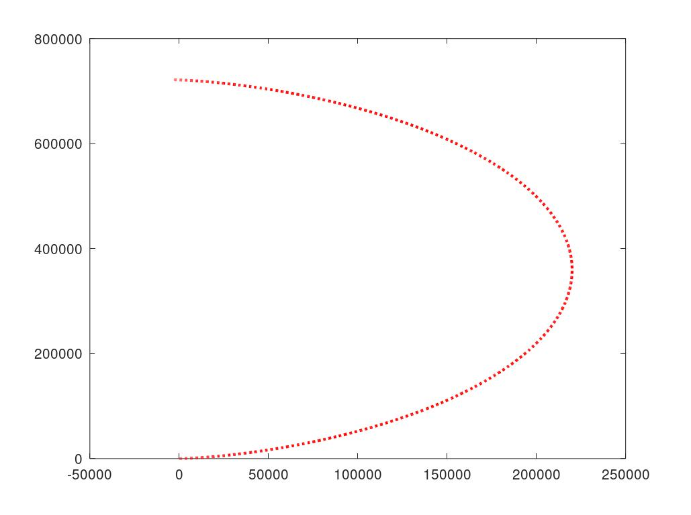
Picture4

