Land, Air and Water Vehicle Requirements for Ice Age 2100

Victoria Levkine (email mst@mathship.com)
Guennadi Levkine (email hlevkin@gmail.com)

Mathship Technologies
Gibsons, BC, Canada

Abstract. P

Key words: star activity;

1. Introduction: problem and terminology

The main problem
This article describes …
It proves

2. A

10. Conclusions.

Make it yourself.

11. Acknowledgments.

We are very thankful to researchers who

Picture 1

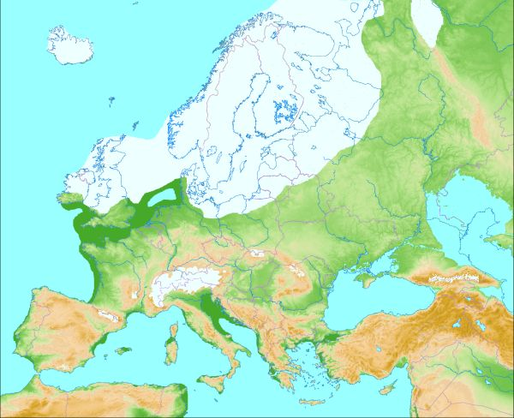

Picture 2 (Glacial map of North America):
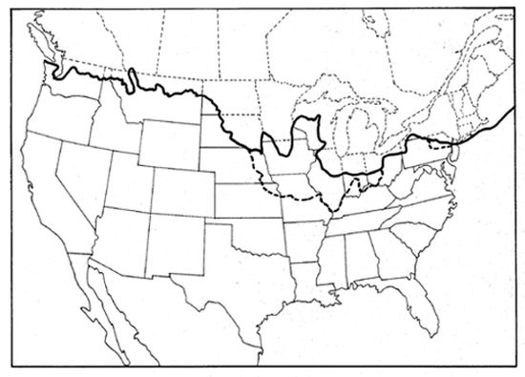

Picture 3 (Glacial map of the Whole World):
