Glaciation in Europe and America in Ice Age 2100

Victoria Levkine (email mst@mathship.com)

Guennadi Levkine (email hlevkin@gmail.com)

Mathship Technologies
Gibsons, BC, Canada

Abstract. P

Key words: star activity;

1. Introduction: problem and terminology

The main problem
This article describes …
It proves

2. A

10. Conclusions.

Make it yourself.

11. Acknowledgments.

We are very thankful to researchers who

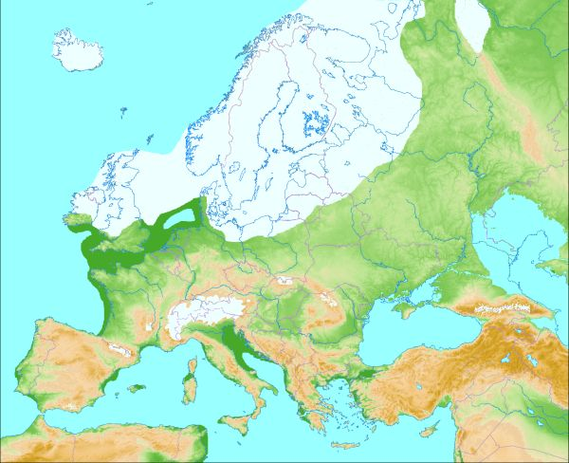

Picture 1 (Glacial map of Europe)

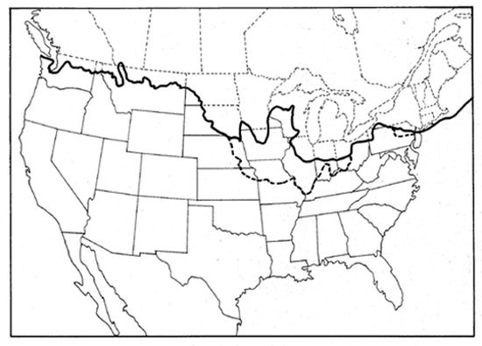

Picture 2. Glacial map of North America
