**Estimation of the energy required for high-speed flights between the stars.**

Guennadi Levkine (email [hlevkin@gmail.com](mailto:hlevkin@gmail.com))

**Mathship Technologies**

Gibsons, BC, Canada

**Abstract.** P

**Key words**: star activity;

**1. Introduction: problem and terminology**

The main problem

This article describes …

It proves

**2. A**

**10. Conclusions.**

Make it yourself.

**11. Acknowledgments.**

We are very thankful to researchers who

Picture 1

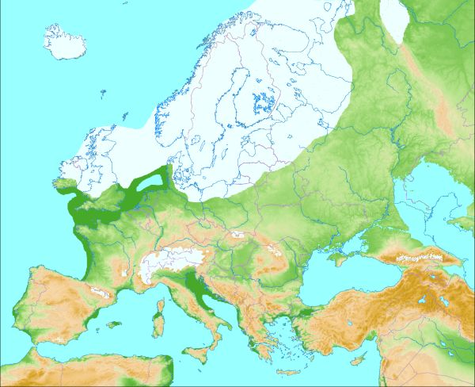

Picture 2 (Glacial map of North America):

