Deviations of the motion of stars from ellipses under the influence of оне planet, rotating around them

Victoria Levkine (email mst@mathship.com)
Guennadi Levkine (email hlevkin@gmail.com)

Mathship Technologies
Gibsons, BC, Canada

Abstract. Deviations of the motion of stars from ellipses under the influence of 1-2 planets. Тhe case where the orbit of the planet is stable (Poincaré problem)

Key words: star activity;

1. Introduction: problem and terminology

The main problem
This article describes …
It proves …

2. A

10. Conclusions.

Make it yourself.

11. Acknowledgments.

We are very thankful to researchers who

Picture 1

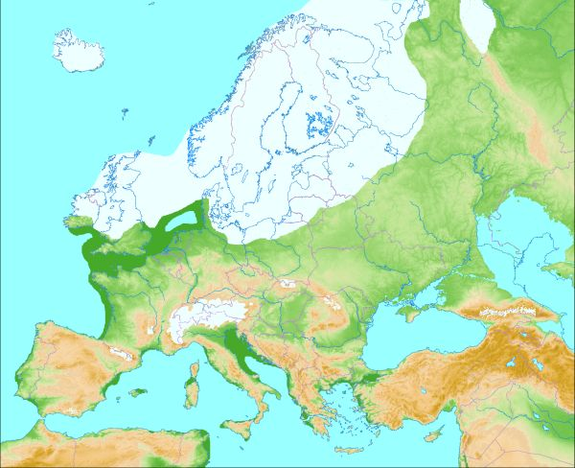

Picture 2 (Glacial map of North America):
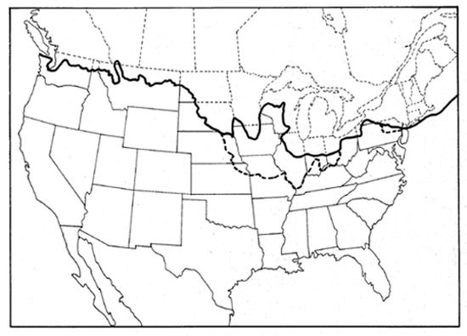

Picture 3 (Glacial map of the Whole World):
